# Playing Hangman

To run hangman.py, locate the script and press “play” at the top right to start the game

Figure Play button

After running the script, it will prompt you for your name. Please only enter letters, dashes ( - ) and forward slashes ( / ) as your name. Once you enter your name, you will enter the main menu of the script.

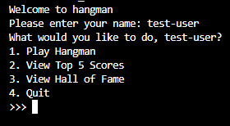

Figure Successfully entering name

Please enter a number (1-3) to use the corresponding feature or ‘4’ to exit the script.

## Play Hangman

Enter ‘1’ in the main menu to be shown the rules of hangman. After reading the rules, you may enter ‘Y’ to play the game or enter nothing (i.e press enter without any other values) to quit

The rules are:

1. A player may play up to **3** games of hangman
2. There will be **3** sets per game, and each set consists of guessing one word
3. A player may use up to **2** lifelines per game but lose **4** points for each use. The lifelines may be used to:
   1. Show the meaning of the word
   2. Reveal all vowels in the word
4. The set will end when the player makes 5 incorrect guesses or guess all the letters in the word
5. Each correct letter guessed awards the player with 2 points
6. Maximum points a player can get in a game is 10 times the number of sets in the game (default **30**)
7. A player is considered to have won if they score at least half of the maximum points (default **15**)

All values in bold may be changed by the game admins

For every set:

1. Every word is considered “Simple” or “Complex” based on the number of characters (excluding space) it has

* Simple words have less than 10 characters and complex words have 10 or more
* While the different word type has no explicit changes on scoring, a word with more characters will tend to have more unique letters to guess and score with

1. Any spaces and revealed letters (i.e letters player guessed) will be shown, and all unrevealed characters will be shown with an underscore (_)
2. A player may guess a letter (a-z) or an apostrophe ( ‘ ) that they have not tried yet

* The letter is not case-sensitive

1. If the letter the player guess is found in the word, all occurrences of that letter in the word will be revealed, and the player gets 2 points
2. If the letter the player guess is not in the word, the man in the hangman will be gain an additional body part
3. The game ends if the player guess a wrong letter 5 times (and the man gets fully drawn) or when the player guesses all the letters in the word

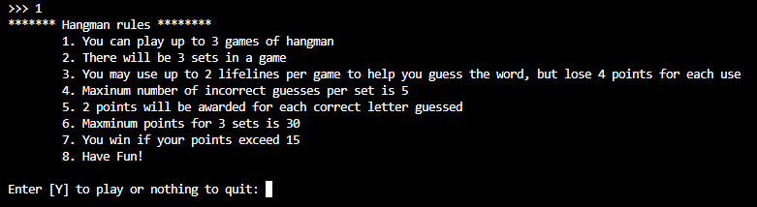

Figure Sample of printed hangman rules at default settings

If you opt to play the game, the game will start immediately. The screen will display the following information about the game (from the top):

* Current game
* Player name
* Current set
* Hangman ascii art
* Incorrect letters guessed and count
* Word to be guessed (with hidden characters displayed as underscores)
* Word meaning, if lifeline is used to reveal meaning
* Remaining lifelines for the game

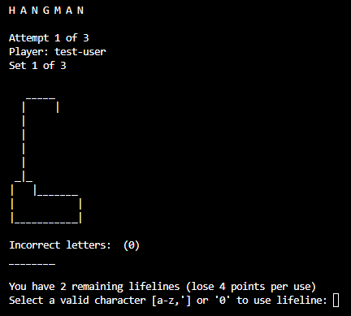

Figure Sample of hangman game in progress

If a correct letter is guessed, the letters will be reveled throughout the word

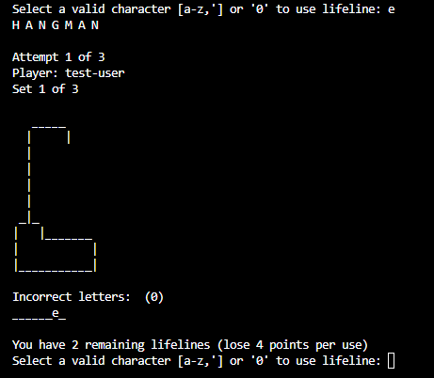

Figure Sample of correct guess

If a wrong letter is guessed, the man at the hangman will be drawn, and the incorrect letters guessed, and counter will be update

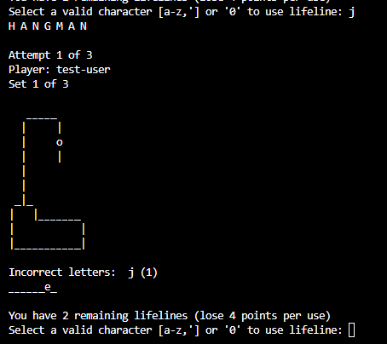

Figure Sample of wrong guess

The player can also enter ‘0’ to choose a lifeline to use. You may then enter a number to get the corresponding hint or enter nothing to cancel using the lifeline. Note you may not try to use the same hint twice for the same word in a game

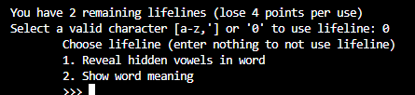

Figure Lifeline menu

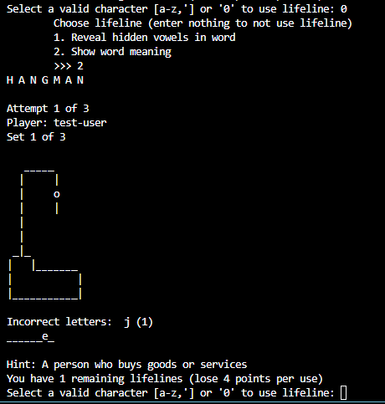

Figure Sample of 'word meaning' hint used

When the game is finished, the player will be shown the word and its meaning and be prompted to enter ‘Y’ to continue to next set or ‘N’ to quit early and return to the main menu. Note that if you quit before the game is over, the game will be incomplete and not be recorded, but still counts as a game played.

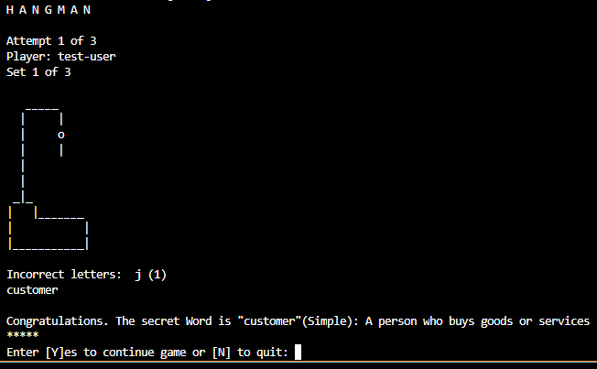

Figure Sample of display when word is guessed

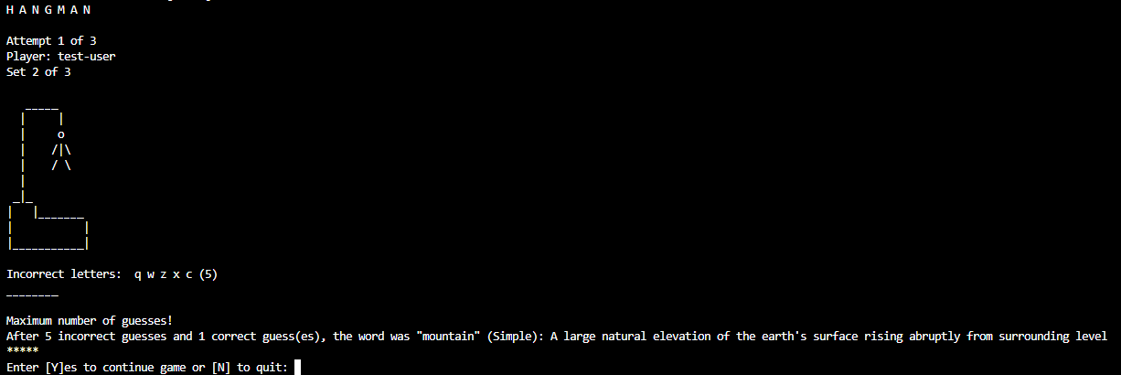

Figure Sample of display when player makes 5 incorrect guesses

When a full game is completed, your score for the game will be displayed, and you may choose to enter ‘Y’ to play another game if you still have remaining games to play, or ‘N’ to stop and return to the main menu. A player who scores the max score in a game without using any lifelines will be recorded in the “Hall of Fame”

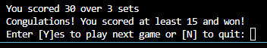

Figure Sample of display of game won

## Display Top

Enter ‘2’ to show the top scoring games. The list will show games of a specific set number (e.g if the current session allows the player to play 3 set games, this option will only show games with 3 sets). The number of top players can be changed by the admin.

The details shown in the ranking system is:

* Ranking
* Player name
* Score
* Complex words encountered
* Lifelines used
* Date played (DD/MM/YYYY)

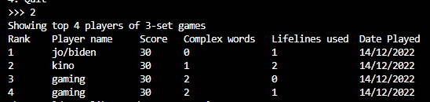

Figure Sample of top games played

## Hall of Fame

Enter ‘3’ to show players recorded in the hall of fame. Players who have scored max score in a game without using lifelines will be recorded and shown with this feature. This will show the player name, and the number of times they have completed such games.A screenshot of a computer

Figure Sample of hall of fame